Tsinghua University successfully held the 4th China refrigeration and air conditioning Industry-University-Research Forum
Provided by Li Junming, Liuyuting, Tsinghua University

On October 12, the 4th China refrigeration and air conditioning Industry-University-Research Forum jointly organized by Tsinghua University and Huazhong University of Science and Technology, co-organized by Gree Electric Applications, Inc. of Zhuhai, Emerson Environmental Optimization Technology (Suzhou) Co. Ltd, Shanghai Hanbell Precise Machinery Co., Ltd, Nanjing TICA Air-conditioning Co., Ltd., Daikin (China) Investment Co. Ltd., Hubei Association of Refrigeration, was successfully held in Wuhan, China. Li Junming, professor of the department of energy and power engineering, Tsinghua University, is the chairman of the forum. Prof. Li Junming participates in H2020—MSCA-RISE-2016-734340--DEW-COOL-4-CDC project and UK-CIAPP\415 project. More than 200 experts and scholars from universities, research institutes, enterprises and academic journals attended the conference.
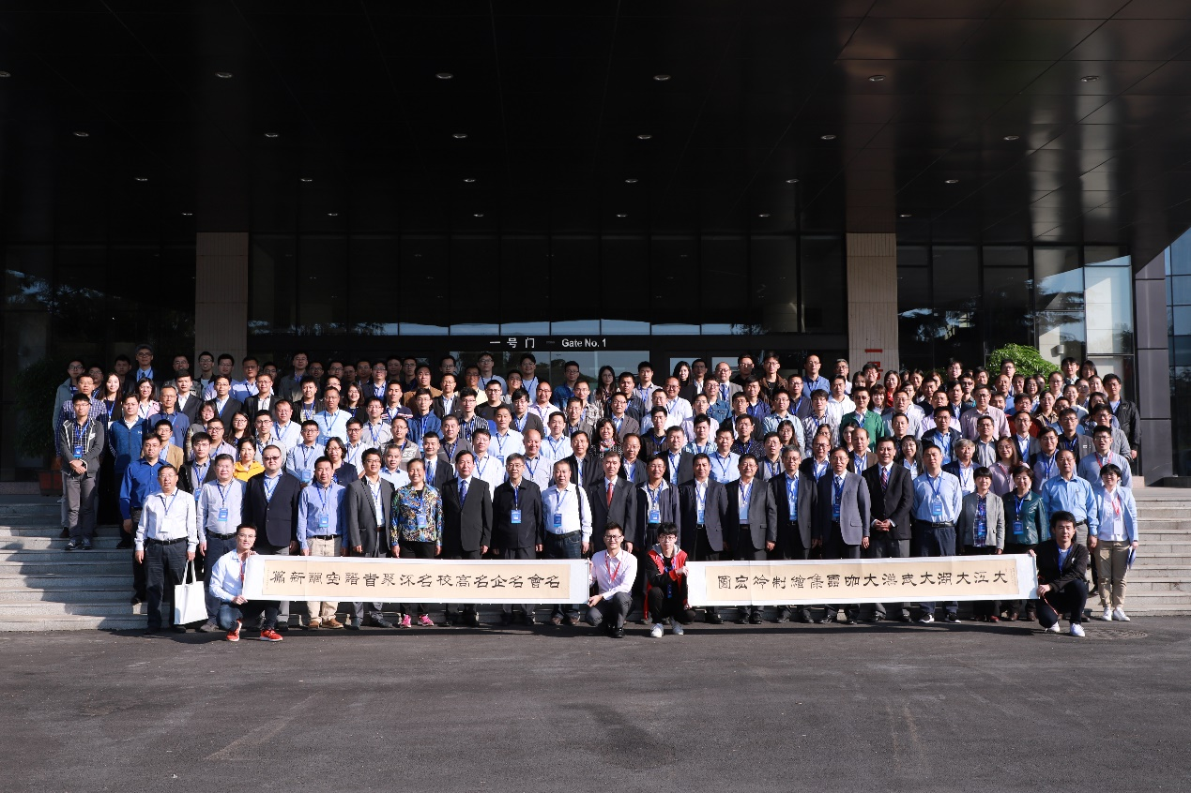

Group photo of all participants

China Refrigeration and Air-Conditioning Industry-University-Research Forum is jointly initiated and organized by Tsinghua University together with Xi'an Jiaotong University, China Refrigeration and Air-Conditioning Industry Association, Hefei General Machinery Research Institute and China Refrigeration Society to establish technical exchanges and information sharing platform in the field of refrigeration and air conditioning, including advanced refrigeration and heat pump systems, high-performance refrigeration compressors, refrigeration and air conditioning control, working fluid replacement, clean heating technology and etc. The forum is held every two years in China.
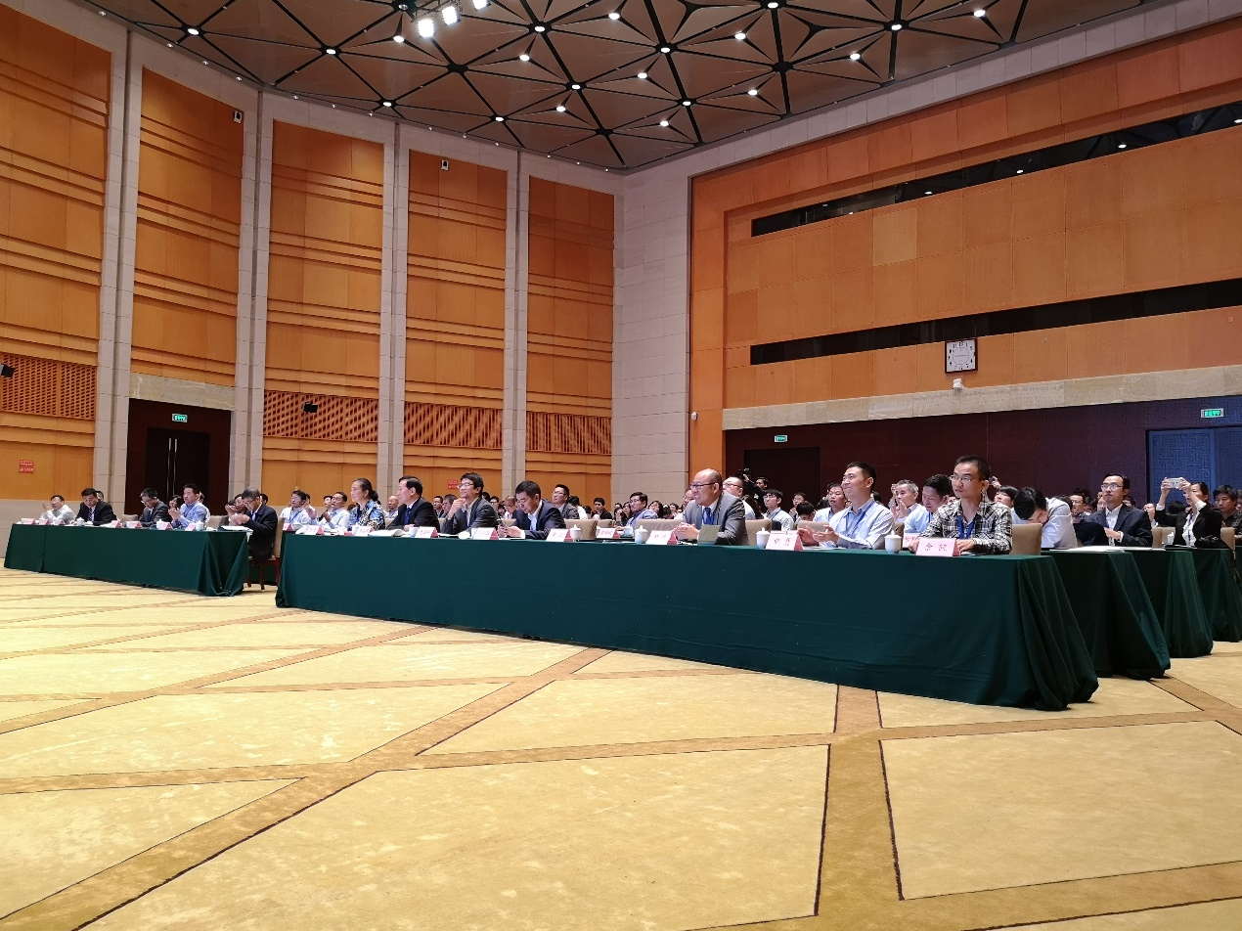
Opening ceremony
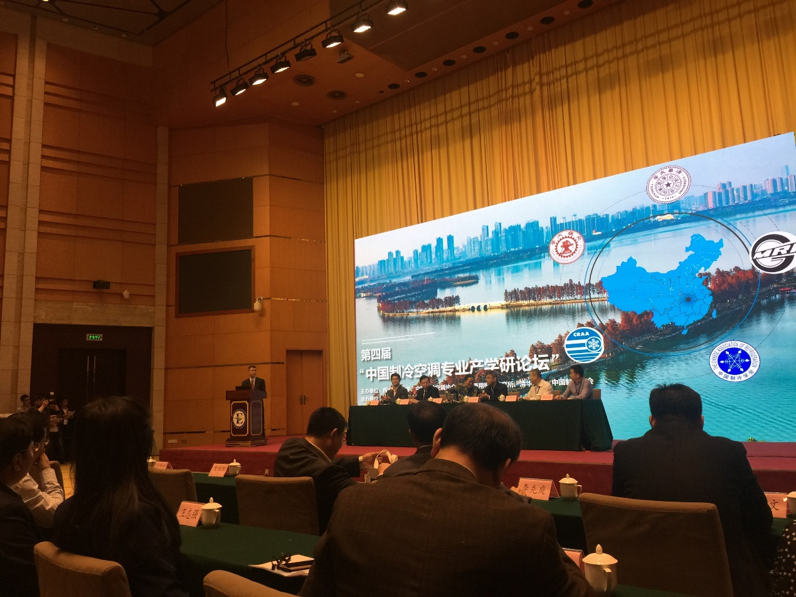
Open ceremony of the conference
On the opening ceremony, Prof. Wu Yezheng, honorary chairman of the conference, from XI’an jiaotng University, Mrs. Shi Min, president of China refrigeration and air conditioning industry association, Mr. Fan Haibin, director of Hefei General Machinery Research Institute, Mr. Jin Jiawei, president of Chinese Association of Refrigeration, Mr. Jiang Xiuying, secretary-general of Hubei Association of Refrigeration and Prof. Li Junming, the chair of the conference delivered the keynotes respectively.
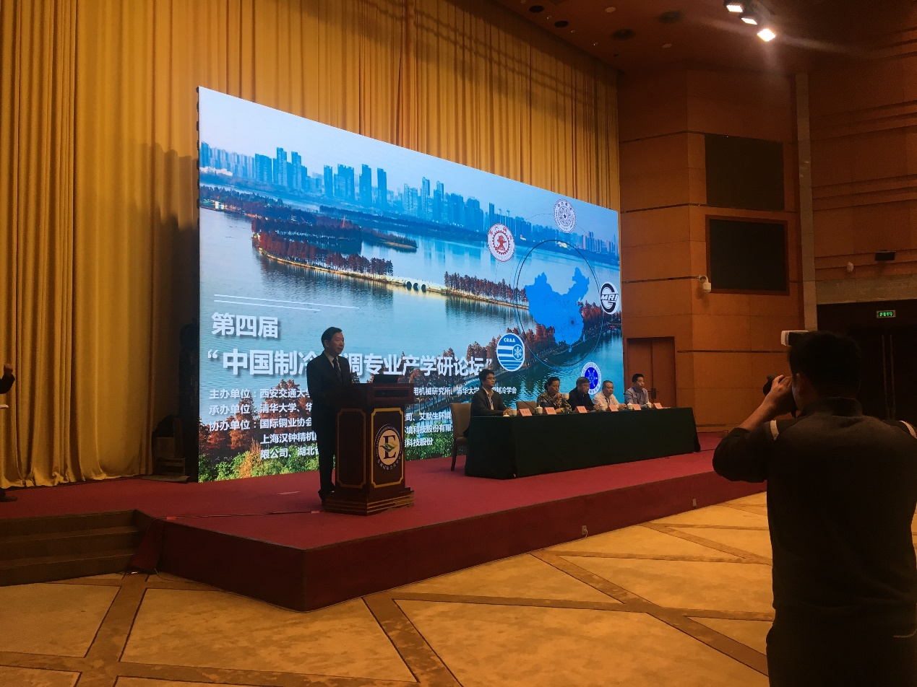
Prof. Li Junming making keynote at the open ceremony
At the conference of day 1, 13 experts including Prof. Zhang Hua, vice president of University of Shanghai for Science and Technology, Prof. Shen Jiang from Tianjin University of Commerce, Mr. Yin Guangwen, vice president of Emerson Environmental Optimization Technology (Suzhou) co. Ltd., Mr. Zhou Min, chief engineer of China Northwest Architecture Design and Research Institute, Prof. Li Junming and so on made invited plenary reports respectively.
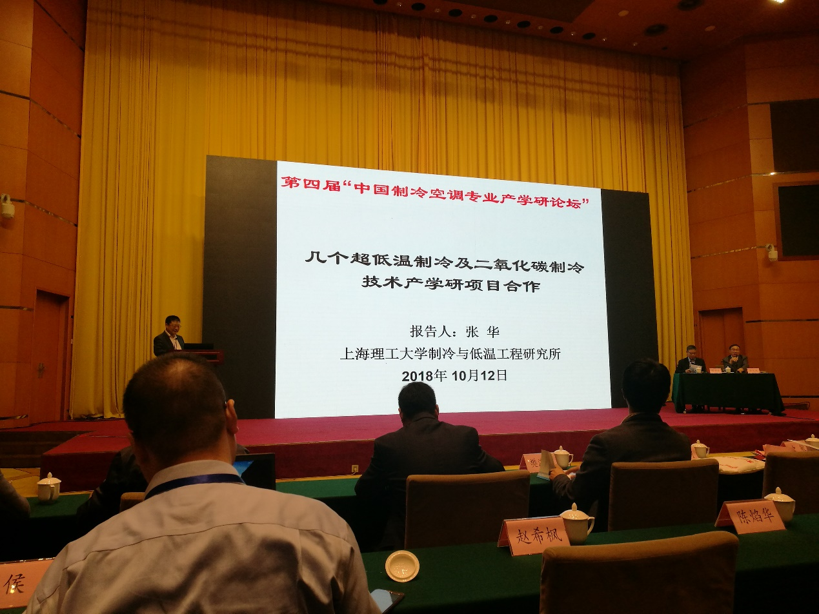
Prof. Zhang Hua making plenary report

Prof. Zhang Hua introduced the Industry-University-Research projects they have undertook about ultra-low temperature refrigeration and carbon-dioxide refrigeration. Prof. Shen Jiang introduced the development of food cold chain technology. Mr. Yin Guangwen from Emmerson introduced the technology progress and application of Emmerson. Mr. Zhou Min gavea report on the refrigeration technology for large space building. Prof. Li Junming introduced the significance, progress and achievements of H2020—MSCA-RISE-2016-734340--DEW-COOL-4-CDC project and UK-CIAPP\415 project. Mr. Yu Kai, minister of Gree, introduced the application of big data in refrigeration air conditioning. Prof. Chen Huanxin from Huazhong University of Science and Technology made a report on China Data Center Cooling Technology. Mr. Zhong Ming, minister of Daikin, talked about the development trend of near zero energy-consuming building and air conditioning. Mr. Zhou Hua, technical director of Hanbell, introduced the application of precision screw compressor of Hanbell. Prof. Hou Yu from Xi’an Jiaotong University delivered the report about application of high-speed turbine technology in the field of refrigeration and air conditioning. Mr. Wu Xiaoquan, director of NANJING TICA CLIMATE SOLUTIONS CO. LTD. Showed the application of their system integration technology in the field of purification air conditioning. Mr. Chen Yanhua, deputy chief engineer of CITIC General Institute of Architectural Design and Research Co., Ltd., introduced Innovative development and engineering application of geothermal energy technology in China. Mr. Cheng Jianghong from China National Institute of Standardization gave the report about the status of energy efficiency for China's refrigeration and air conditioning products and the promotion of energy efficiency standards.
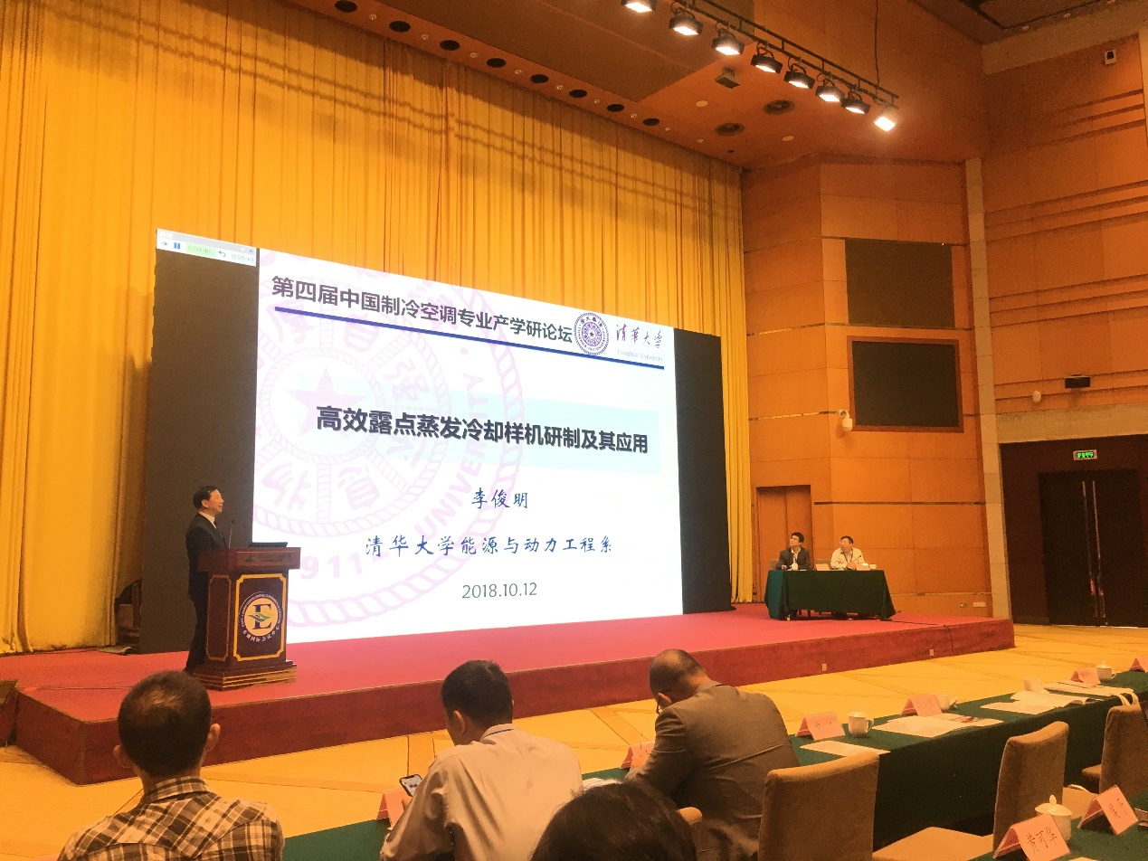
Prof. Li Junming making plenary report
On the second day, the conference was divided into four forums for different themes, including heat pump system and technology, Hvac technology, Heat exchanger and heat transfer enhancement techniques, and refrigeration and cryogenic technology. Every parallel sessions had 1 invited report and 16 chosen excellent paper reports.
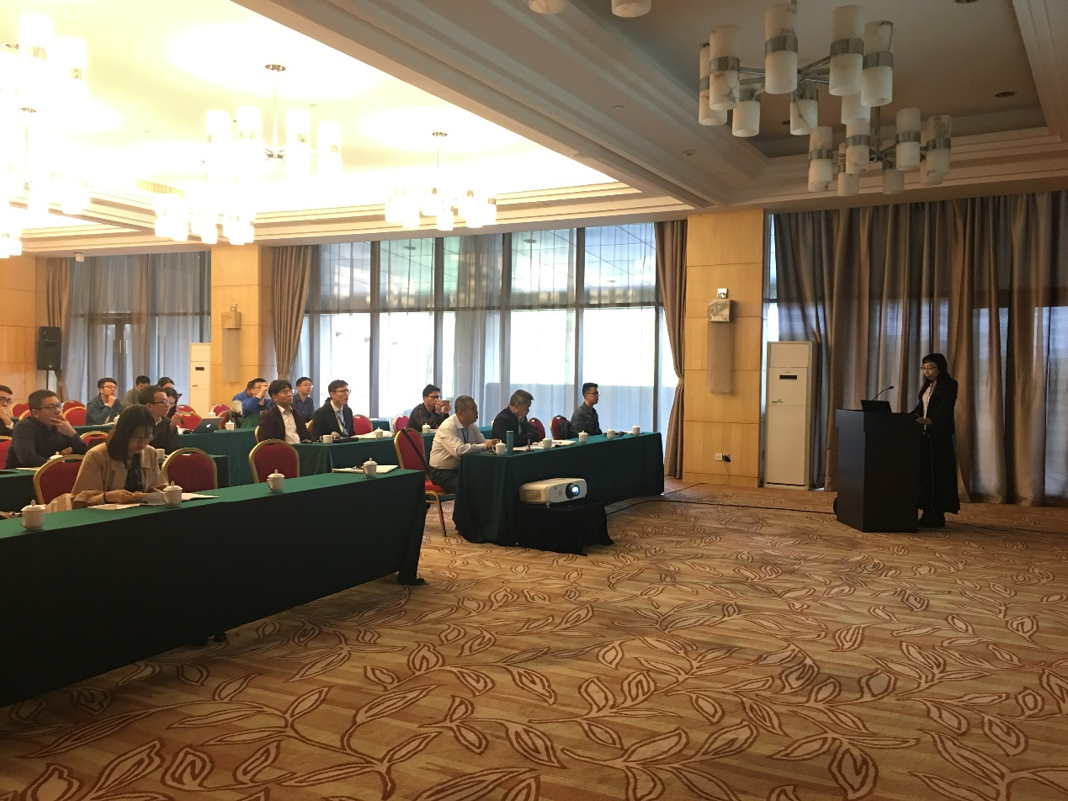
Invited report on parallel session
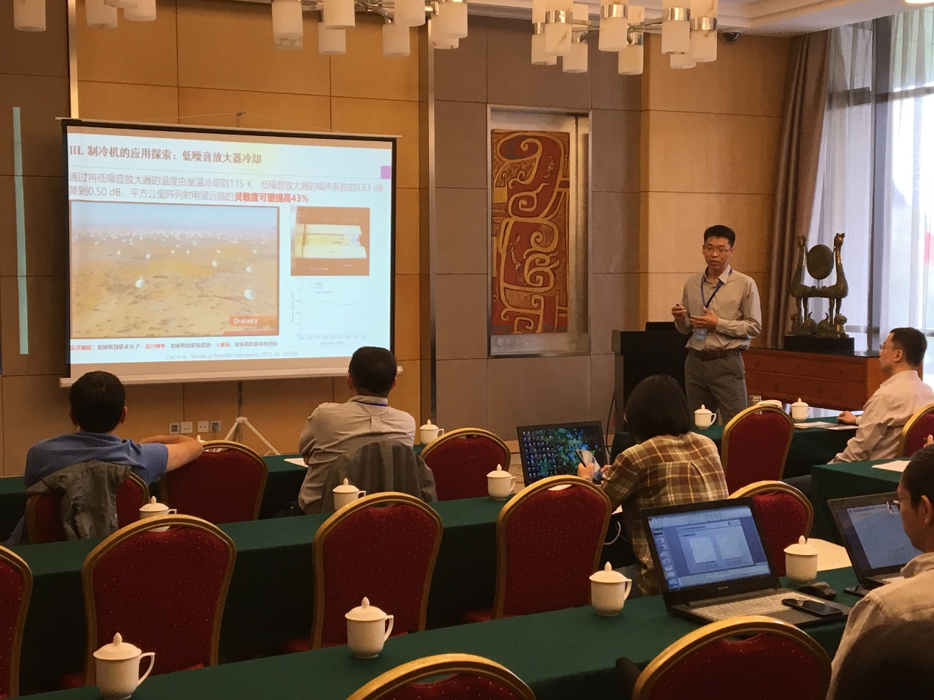
Invited report on parallel session

